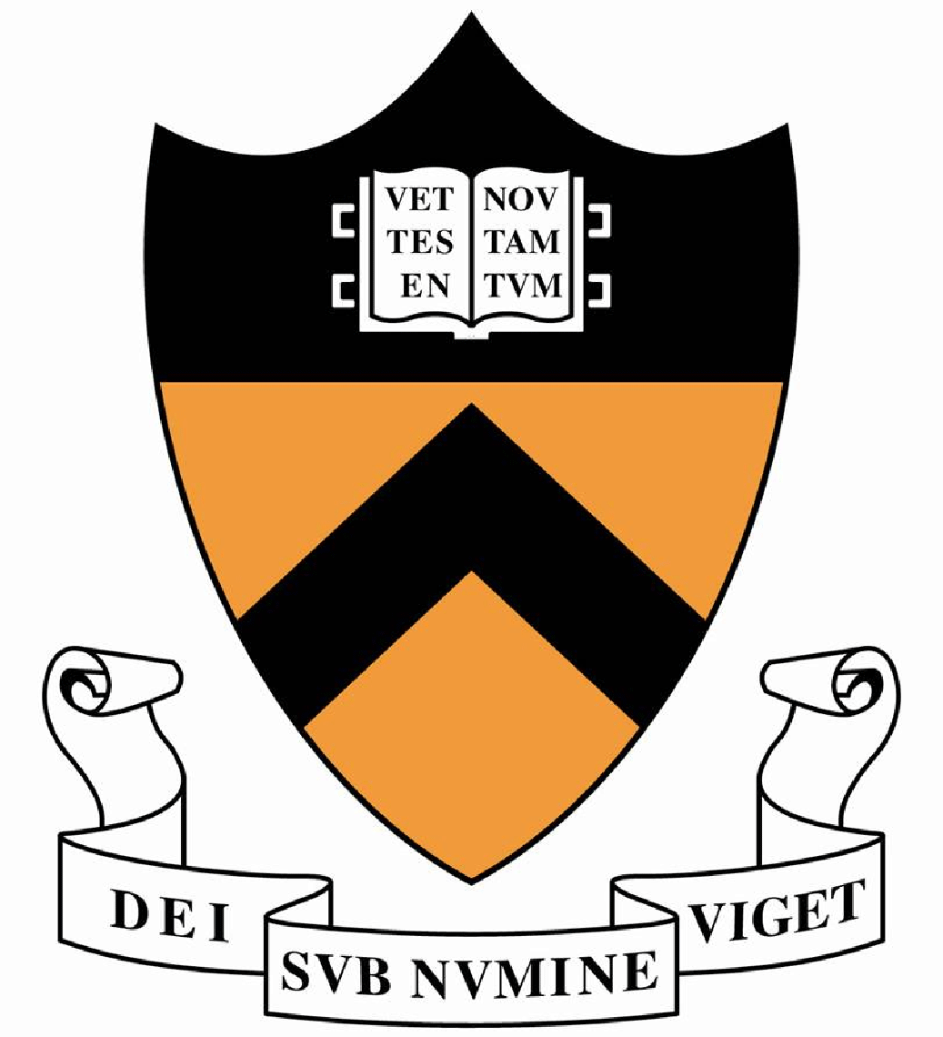
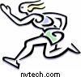
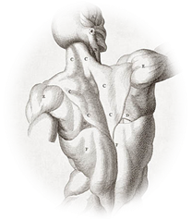
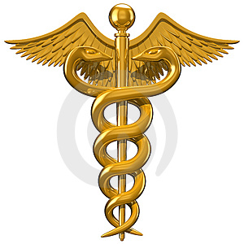
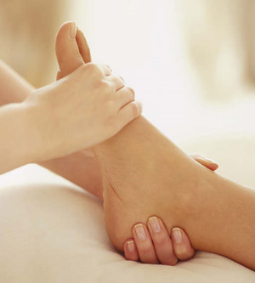
Joy L. Meyer, M.D.
Board Certified, July 1998
American Board of
Physical Medicine & Rehabilitation

For Appointment, Contact:
General Orthopedic
1659 Central Ave.
Colonie, NY 12205
(518) 869-0021
Fax: (518) 464-9160

- Compassionate Care at Your Pace
- Unsurpassed Skills & Understanding of the Musculoskeletal System, Movement, Exercise, and Neuromuscular Retraining
- The Convenience and Benefit of Coordinated Care with the Finest in the Field of Foot Orthotics; Art Smuckler C-PED, Will Smith C-PED, MSPT
- The Most Up-to-Date Advancement in Treatment: Prolotherapy Injections to Facilitate Tissue Regeneration and Healing

Consider This:
Joy L. Meyer, MD
Doctor and Specialist in
Physical Medicine & Rehabilitation
What can she offer you?

- A thorough history and physical exam
- Expertise in diagnosing the cause and source of pain, injury, and decrease in abilities (even when standard tests have not been helpful)
- A biomechanical assessment determining factors contributing to the dysfunction
- Individually designed treatment program and discussion of therapeutic options
- Restoration to maximum activity without surgery
Education:
- B.A. Princeton University ’82, Biochemistry Major
- Doctor of Medicine ’89, University of Maryland
- Residency PM&R ’97, Albany Medical Center

Top Athletic Accomplishments:
- Multiple Ivy League Championship titles ’78-‘82
  - Princeton Cross Country, Indoor & Outdoor Track
  - “All-Ivy”; Senior Athlete Award
- High School Senior Athlete of the Year ‘78:
  - Varsity Captain Soccer, Basketball, Track
Other interests:
- Medical Missions
- Coaching/Sports Training

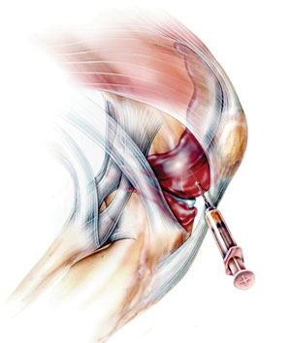
Dr. Meyer offers a proactive approach to problems that perhaps you thought you just needed to accept, even though they negatively impact your daily life.
She offers an alternative to using solely pain killers or receiving steroid injections which may merely be masking symptoms or put you at risk for future injury.
Pain from arthritis, bursitis, tendonitis, disc problems, whiplash, nerve impingement, cartilage damage, fibromyalgia, strains, overuse injuries, chronic illness, etc. require a hands-on evaluation and often involve the entire kinetic chain. A foot problem may have originated from weakness in the hip and vice versa. The upper and lower core and even the way you breathe affects the neck and back. The shoulders and knees often take the brunt of overall deconditioning.

Dr. Meyer will determine whether you are also a candidate for prolotherapy.

Physical Medicine & Rehabilitation

What is Prolotherapy?
Injury to ligaments causes them to be overstretched and weak and much too loose to be supportive. Their job is to support joints, thus the joints become unstable. This instability often leads to muscles overworking in an attempt to compensate, which results in muscle spasm, trigger point pain, or achy fatigue. There is also increased wear and tear on the cartilage, the capsule, and the joint and eventually the pain of arthritis.
The tendons (in particular where they attach to bone) get chronically inflamed, become friable and weakened, are unable to handle the load of repetitive use or muscle deconditioning, and not only hurt but eventually can tear (as in a rotator cuff tear).
Exercise therapy addresses muscles and proper mechanics. Prolotherapy heals the injured tissues in and around the joints (i.e. in the knee or the spine). It strengthens ligaments and tendons and takes away pain. It involves the injection of a safe solution causing a natural local reaction, which increases blood supply and flow of nutrients and stimulates tissue repair. It is less traumatic to the body than arthroscopic, microscopic or open surgery and there is no down time or months of recovery. It is also very affordable.
Dr. Meyer has had 10 years of extensive training and experience in prolotherapy.

Orthotics and exercise add support to the foot and improve gait and alignment; Prolotherapy can repair damaged tissue that is the cause of many painful foot ailments like Plantar Fasciitis, Achilles Tendonitis, and Bunions.

